ASSIGNMENT 6

Q1. CREATE THE ERD ON THE MS VISIO  
  
FOR THE ONLINE ATTENDANCE MANAGEMENT SYSTEM IN THE COLLEGE.  
  
USE PK, FK, CARDINALITY CAREFULLY IN THE DIAGRAM...

Solution

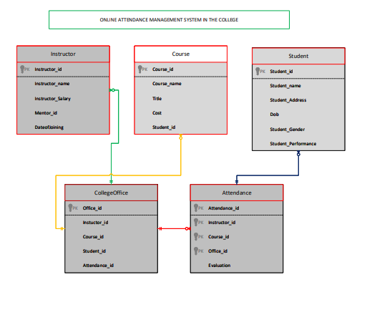

Q2.  CREATE THE DFD [ LEVEL-1] ON THE MS VISIO  
FOR THE ONLINE ATTENDANCE MANAGEMENT SYSTEM IN THE COLLEGE.

Solution

